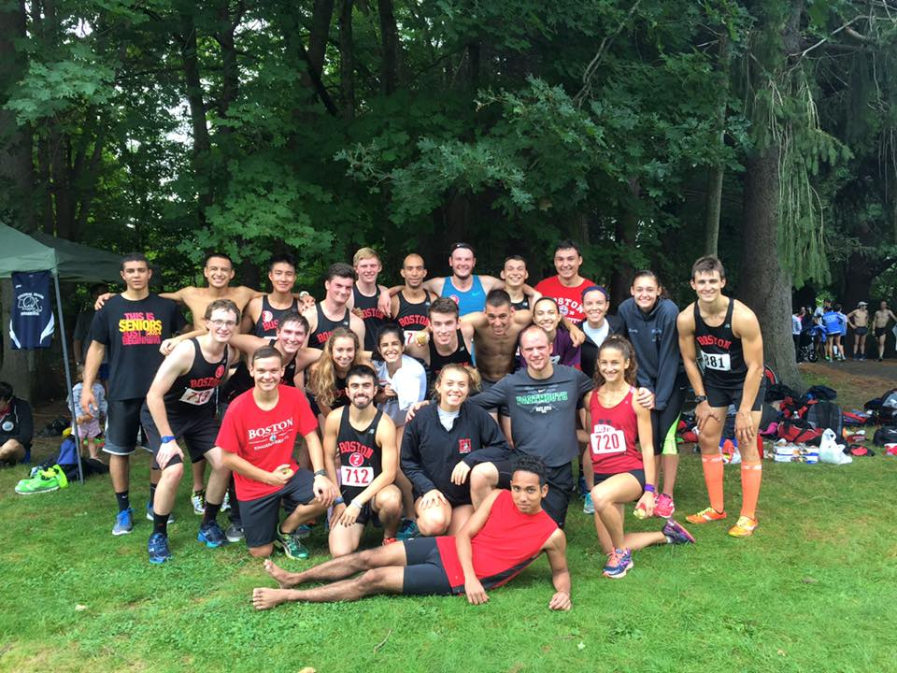
Boston University Running Club
Year-In-Review: 2015-2016

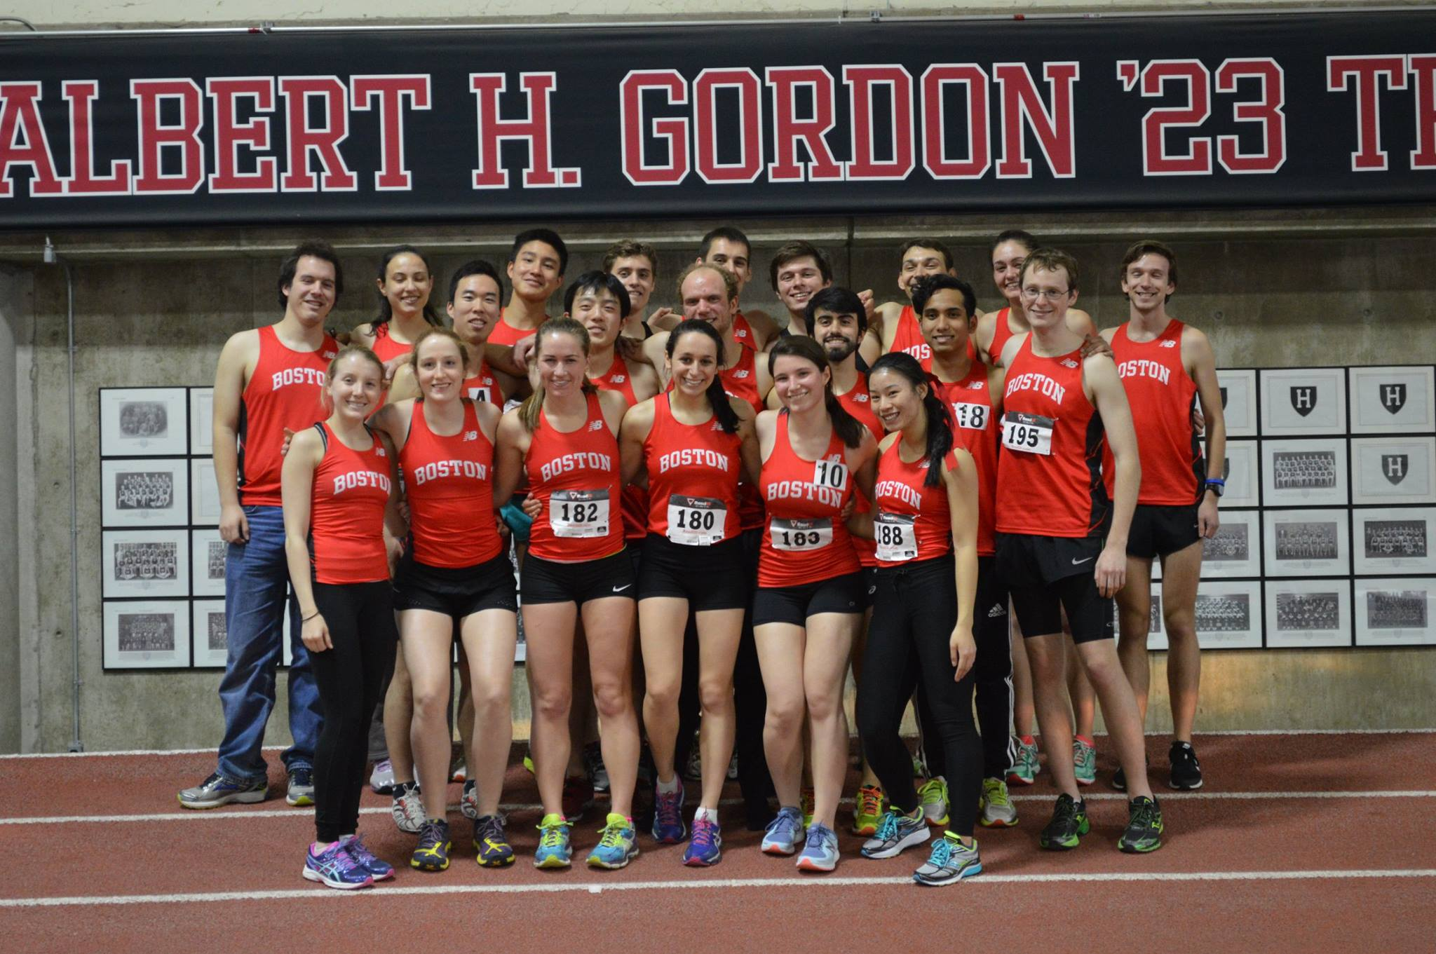

Overview:

As of summer 2016, our club has continued to grow in competitiveness since this component of the club was introduced 5 semesters ago. We are committed to an all-encompassing running club, accepting competitive and non-competitive runners of all skill levels and abilities. We race three distinct seasons: Cross Country/Road Race (fall), Indoor Track (winter), and Outdoor Track (spring). What began with about 10 active members in early 2014 has since grown to an organization with upwards of 60-70 members throughout the year, maintaining a consistent roster of around 30 active members, participating in our activities both competitively and recreationally. We are very grateful and appreciative of all the support we have received as a club throughout this past year, from our school, our advisors, our executive board, our members, and all of our various connections. We have witnessed many personal bests and club records over these past few seasons, and we hope this trend continues. In addition, we hope to bring in new members who are looking for a supportive running group. Throughout the next year, we seek to grow both as an organization and as individual runners.

Races:

9/13/2015
We opened our competitive Cross Country season with our very own co-hosted meet, the Terrier & GBTC XC Festival. This meet was sponsored by NIRCA, our governing body for intercollegiate running club racing, and it was our first time hosting a NIRCA meet as a club. We had a great turnout with 15 BU competitors on the men’s side and 8 BU competitors on the women’s side. Nate Michener led the way for the BU men, finishing the 5K distance in 17:34, closely followed by Sam Depalma in 17:37. Eric Leohle notched a personal best, running 18:19. Gab House finished in 19:14 to place first for the BU women, followed by Lorela Blaka in 20:13.

9/26/2015
After a couple weeks of workouts and group runs, the club sent out to compete at the NIRCA Harvard Invitational in Belmont, at the Rock Meadow Conservation. This true cross country course wound through the trees, with challenging rocky terrain, hills and a footbridge over a stream. Nate Michener crossed the line first for BU, finishing 8K in 29:13, and David Martinez won a closely contested battle for second on the team with a 29:47. Gab House, who broke the course record, led the women’s team again along with Lorela. They were followed by a stellar performance from Michelle Alessandro, who finished the 6K distance in 24:31. The girl’s team, including Adrianna Wurster, Annemarie Parsons, Nicole Milani and Molly Kierstead, placed third overall for their efforts.
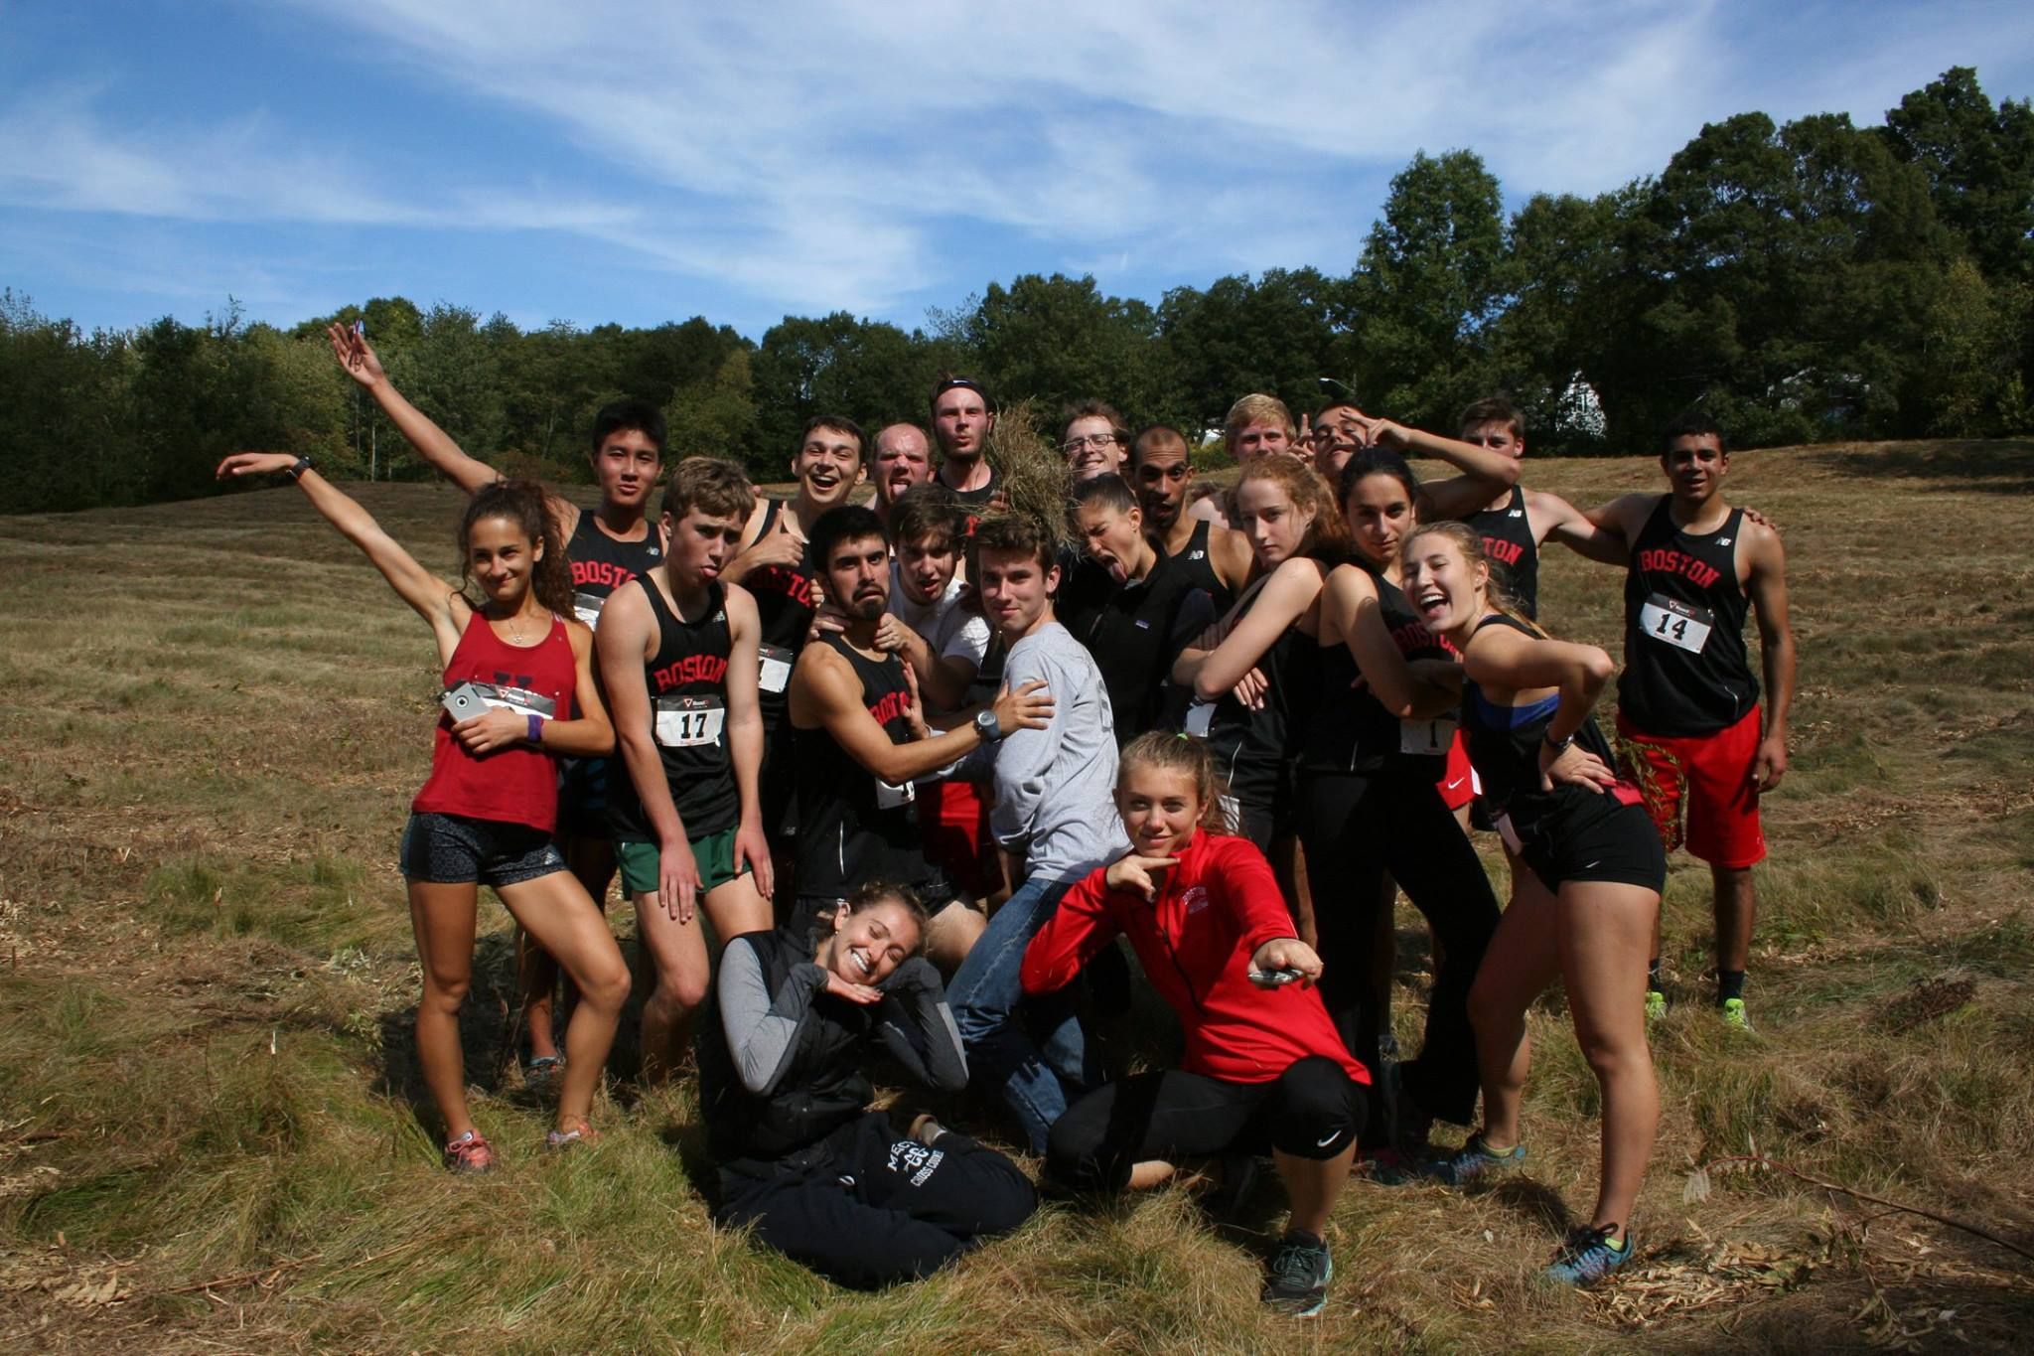
Funny team photo after the Harvard XC Invite
9/27/2015
On a nice sunny day in Allston, several members of our club entered the Brian Honan 5K, which offers free entry to BU students. This was the second race in two days for some of our competitors. Erik Wong placed first for the BU team, finishing 5K in 19:26, followed by our other racers: Gab House, Dakota Wyne, Alex Oleinik, Dan Kelly, Sandra Wilson, Ryan Smith, Laura Marshall, Morgan Ashurian, Willow Yeoh, Annie Lane and Nate Michener.

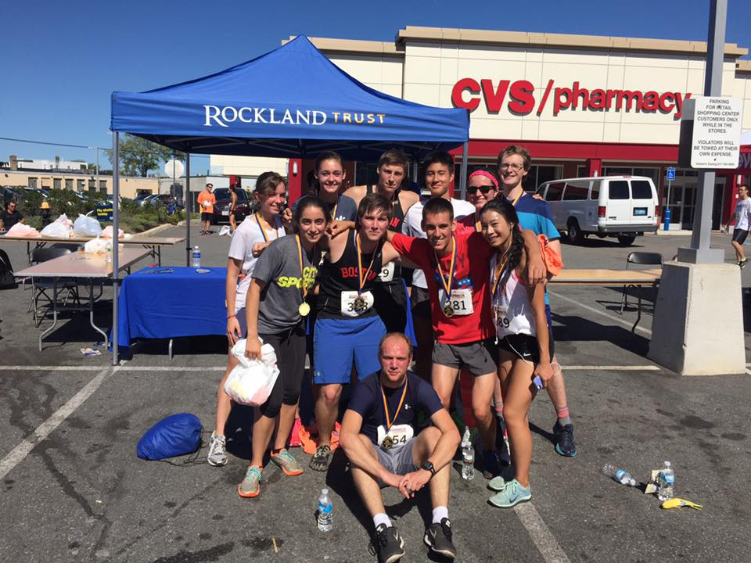
Team Photo after the Brian Honan 5K in Allston
10/9/2015
Over Columbus Day weekend, many of our members celebrated by heading out to compete at the Wayland XC Invite. Jeremy Gonzalez got the team win, finishing 5K in 18:02, followed by Sam, Daniel, Cole, Tyler, Christian, Alex, James, Jordan, Jake, and Aaron, for the men. Gab placed first of the BU girls, followed by Laura Marshall and Kailin Ambwani.

10/18/2015
David Martinez finished the Bay State Marathon in 2:56:50, which is not only an incredible time but also a Boston Marathon qualifying time. As reported by the Boston Globe, David heroically missed qualifying for the Boston Marathon by one second in his last marathon race (3:02:33), but he would not be denied this time, as his new PR virtually guarantees him an entry.

10/25/2015
We had another large turnout for the Boston Mayor’s Cup 5K, a popular race favorite among club members at the beloved Franklin Park. The course features a brutal hill, and the event brings some of the biggest names in the sport out to compete. Our men’s team finished in the following order: Nate Michener, Daniel Kelly, David Martinez, Sam Depalma, James Lane, Dakota Wyne, Tyler Takata, Chris Ackerman, Alexander Oleinik, Matt Ciarmitaro, Erik Wong, Ryan Smith, and Matt Mirek. For the women, Michelle Alessandro finished first, with Andrea Castano in second, Izzy Dahlke in third, and Sandra Wilson in fourth.
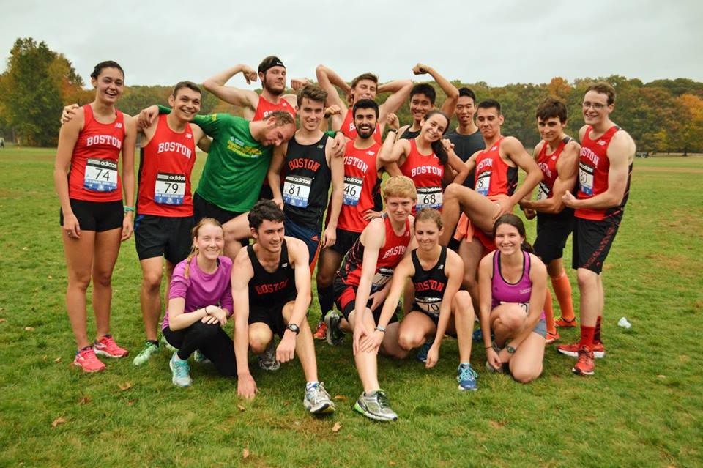
Team Photo after the Boston Mayor's Cup 5K

10/31/2015
At the NIRCA Regionals competition, hosted by Harvard Running Club at Franklin Park, Daniel Kelly showed his distance strength, placing second for the BU men with a 29:03 8K. Nate Michener placed in the top 10 with his performance of 28:21. Michelle Alessandro showed her talents in the women’s 6K, taking first on the team, and edging out Annie Geasa who ran a strong second.

11/1/2015
Matthew Mirek finished the New York Marathon in 3:54:46 in his marathon debut. He has a quick half marathon to his name (1:27), but an irregular pace hurt his marathon time. We congratulate him on breaking the 4 hour barrier.

11/14/2015
After a considerable amount of behind-the-scenes work from the Executive Board, we were able to send our first ever team to the NIRCA Cross Country Nationals competition in Kentucky. Our seven brave competitors, who outlasted a 15-hour bus ride each way, were Nate Michener, Sam Depalma, David Martinez, Dan Kelly, Alex Oleinik, Eric Leohle, and Annie Geasa. Every single runner had a strong showing on the tough course against top-notch competition, and made the rest of us proud back on campus. We hope this trip was the first of many Nationals appearances to come.
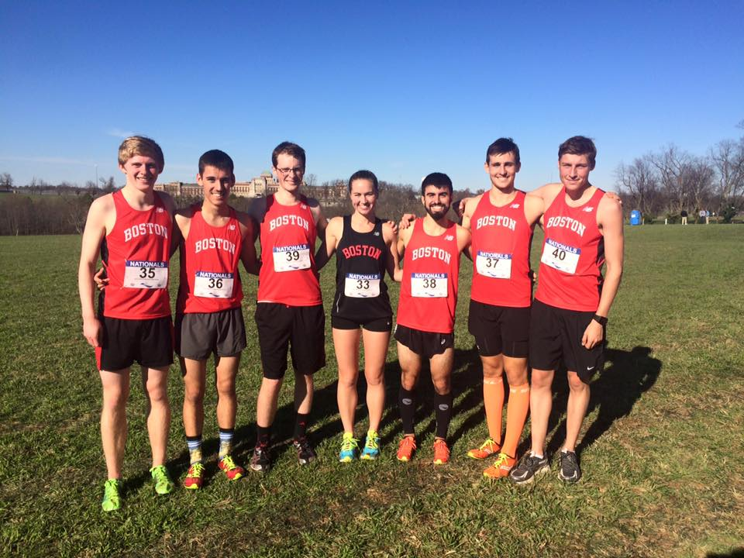
NIRCA Cross Country Nationals competitors
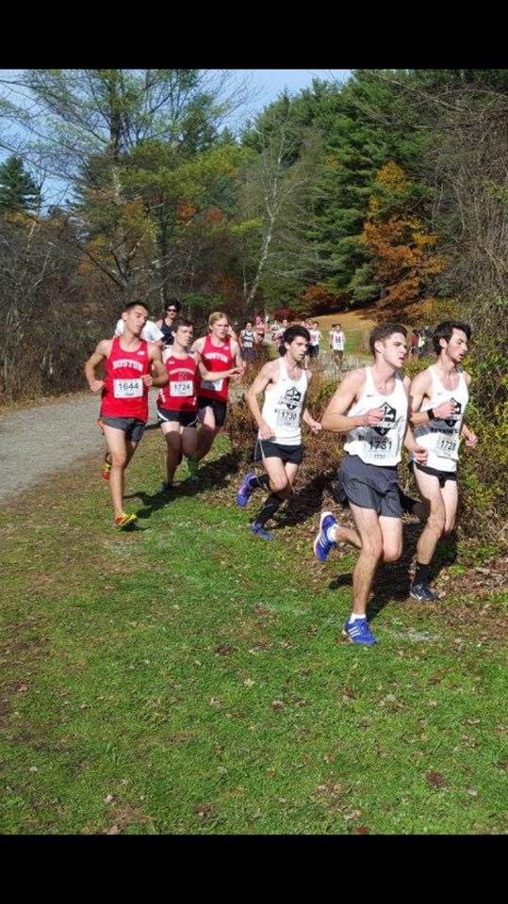
Dan and Sam race against the pack at Nationals

12/5/2015
After nearly a month of rejuvenation and hard training, we began our indoor track season at the UMass Boston Opener. Jeremy Gonzalez ran a strong 800 meter race in 2:01.6, followed by Erik Wong. Nate ran 4:59.5 for the mile, doubling after a strong 5000 performance as well. James Lane and Erik Wong dueled it out in the mile. Our sprinting squad, consisting of Kaito Niwa, Rudi Sriram and Hector Romero, made a rare appearance in the heart-pumping 60 meter dash.
Sandra Wilson ran well in the 800, and Ryan Smith competed in the 400.

At the BU Mini Meets over winter break, Nathan Michener (Mile), Jeremy Gonzalez (800), Natalie Obssuth (Mile) and Gab House (Mile) all ran fast times in their respective events.

1/24/2016
Several club members opened the spring semester at the Greater Boston Track Club invitational.
Riley Pihl ran a strong 3000 meters in 10:13, even with a lack of speed work. Ryan Smith ran a quick 600 meter dash in 1:25, and Sandra Wilson ran a top notch 600 meter time with a 1:43. Nate Michener, David Martinez, and James Lane battled it out in the mile.
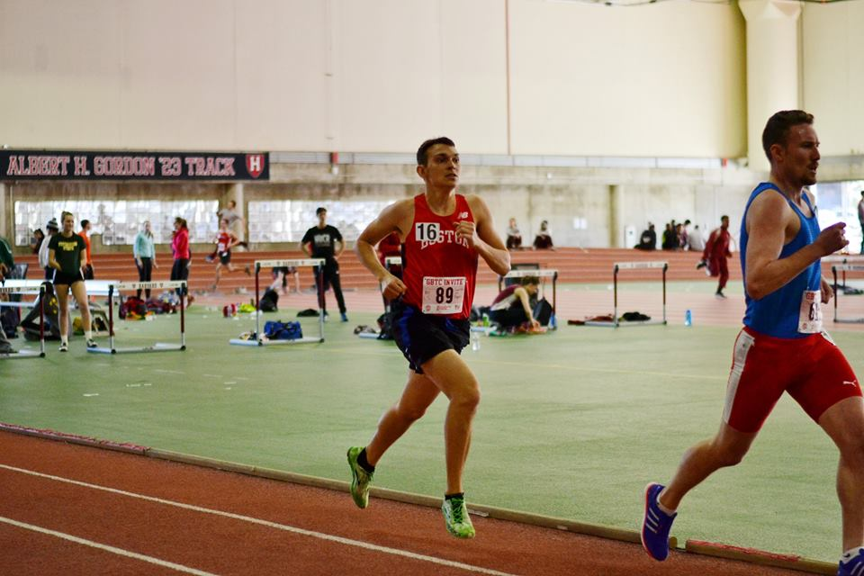
James Lane chases his competitors in the Mile

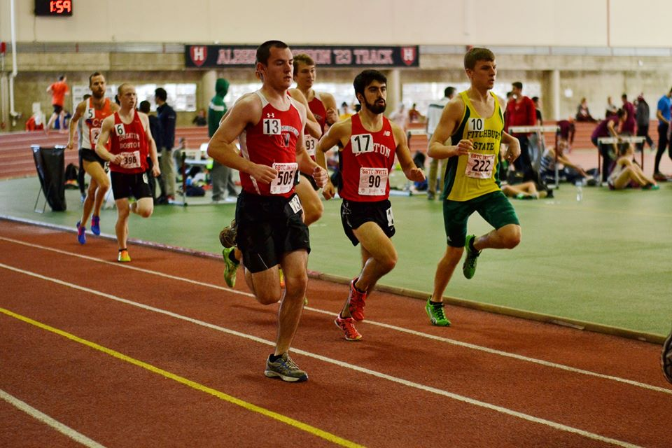
David Martinez paces with the pack in the Mile
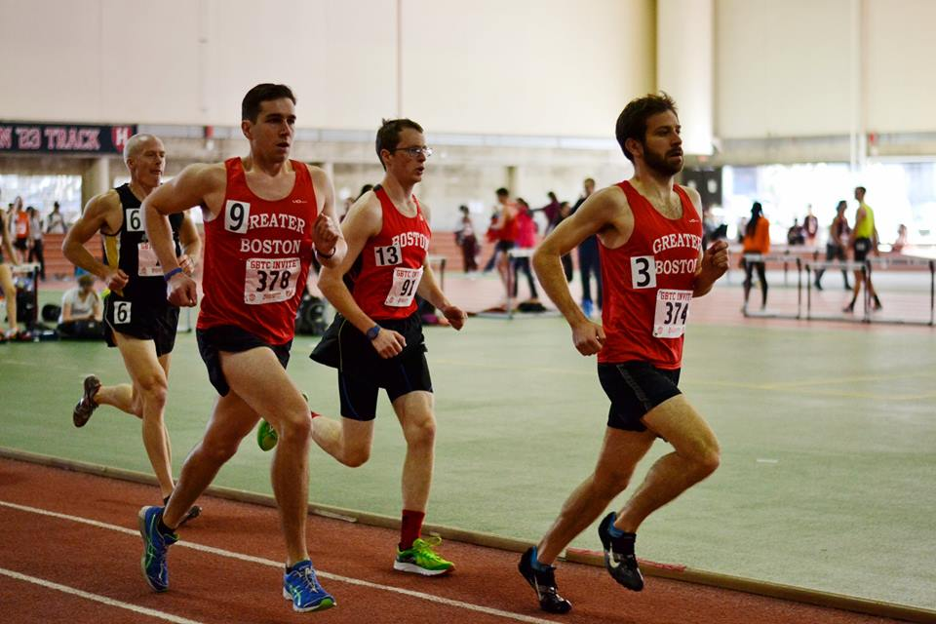
Nate races against post-collegiate runners in the Mile

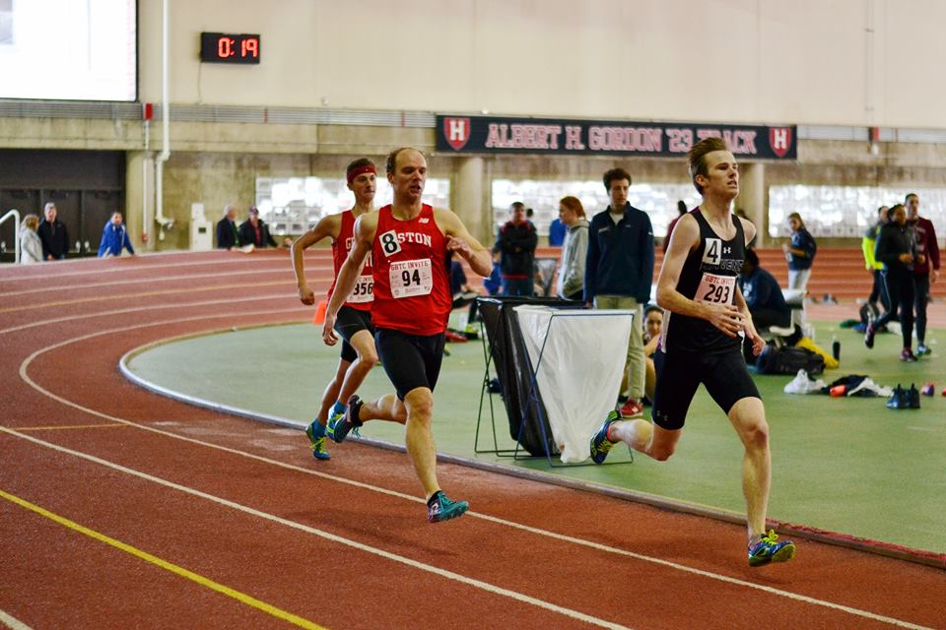
Ryan Smith cruises down the home stretch in the 600

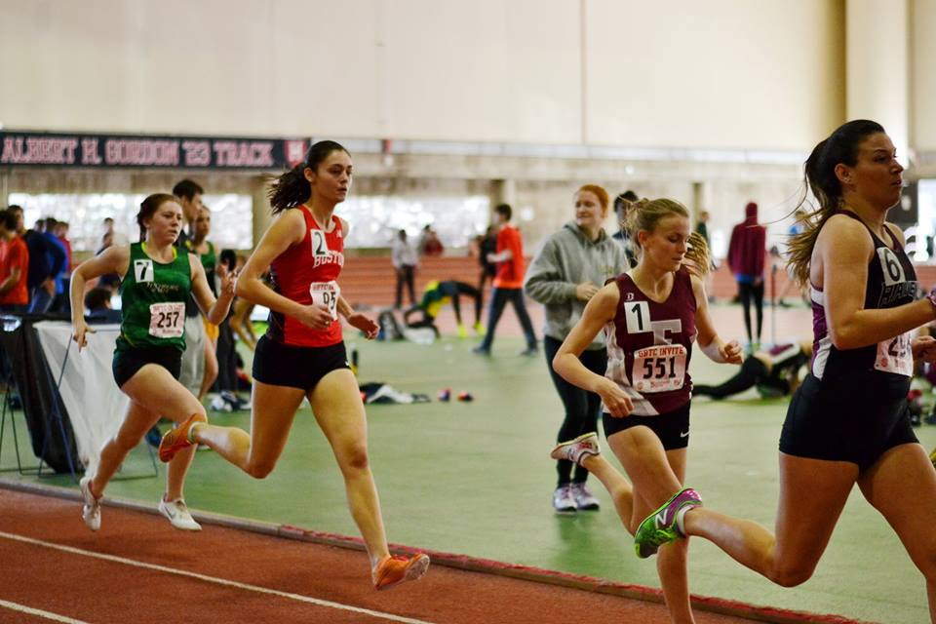
Sandra Wilson races the 600 in the fast heat

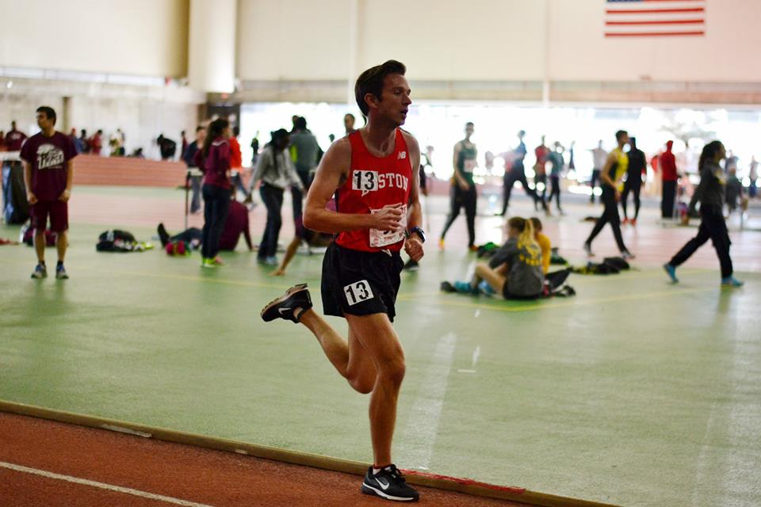
Riley pushes through the pain in the 3000

2/6/2016
Our club utilized “home field advantage” at the Scarlet and White Invitational, hosted at the BU Track and Tennis Center. Matt Soriento represented our sprint squad, burning up the track with a 23.89 200 meter dash. Sandra Wilson extended her range to the 800 meters, finishing in 2:28.05, and Ryan Smith showed his mid-distance strength with a 2:01.85 800 meter run. Annie Geasa set a new club record in the mile, running an exceptional 5:27.40, followed by Michelle Alessandro in 5:31.75 (under the old record as well). Nate, Riley, Erik ran the mile for the men’s team.

2/13/2016
Again visiting our home track and daily practice facility at the BU Track and Tennis Center, our club made a showing at the Valentine Invitational. Ryan Smith ran a club record in the 800 meters, finishing in 1:59.99, just dipping under the 2-minute barrier. Ethan Barton showed his grit in the 800 meters, running a 2:11.26 with only a few weeks of training. Katio Niwa doubled in the sprints, running the 60 in 7.71 and the 200 in 24.83. Matt Soriento showcased his speed in the 200 with a 23.99. Nate Michener ran a club record in the mile with a 4:44.38, and also led a pack of sub-5 minute BU Club milers consisting of Riley Pihl (4:47.42), David Martinez (4:54.62), and Tyler Takata (4:56.05). Erik Wong (5:08.96) and Cole Wirtz (5:08.97) contested the mile distance as well, which came down to a home-stretch sprint, with Erik winning on the lean by 0.01. The men’s team fielded a 4x400 relay, running a club record in 3:46.

2/27/2016
We concluded our indoor season competing at an exclusive club-level NIRCA meet hosted by Harvard. It’s exciting and rewarding to compete against other runners at a similar skill level, and this meet was one of our few opportunities to achieve this as a club. Although there were many amazing individual performances at this meet, our most notable achievement was the meet attendance, which was easily the most competitors we have ever had at a track meet so far. We had 22 competitors overall, plus a few spectators who took over split timing and photography duties, including: Cam Baxter, Kate Monroe, Erik Wong, Ben Fisher, Daniel Kelly, Ethan Barton, James Lane, Sandra Wilson, Riley Pihl, Tyler Takata, Kaito Niwa, Ryan Smith, David Martinez, Justin You, Nate Michener, Andrea Castano, Annemarie Parsons, Annie Geasa, Michelle Alessandro, Annie Lane, Willow Yeoh, Natalie Obssuth, Kailin Ambwani, Lydia Balestra, Jake Simon, and Jeremy Gonzalez. We hope to expand upon this excitement by hosting our own NIRCA track meet next winter.

4/2/2016
Our outdoor competition season is abbreviated due to the New England weather and the academic calendar. These constraints forced us to open our outdoor season at the Tufts Snowflake Invitional in near-freezing temperatures and rain. Kaito Niwa ran a personal best and club record in the 100 meters with a 12.57. Tyler, James and Erik ran for bragging rights in the men’s 1500, with Tyler coming away victorious. Nate, Riley, Roni toughed out the 5000, a difficult event to run on the track. Sandra Wilson ran a lightning fast and season best in the 800 meters with a 2:24, and Ryan Smith contested the 800 meter distance as well. Annie Lane had a strong performance in the 1500, despite the poor racing conditions.

4/9/2016
Our club sent an ambitious group of members to the NIRCA Nationals & Half Marathon competition in Indiana. Despite a high price tag and weekend-long time commitment, the following members showed their commitment to competition at the highest level. Nate Michener again had a headline worthy performance, breaking the 16-minute barrier for the first time in the 5000 meters with a personal best of 15:59.25. Not to be outdone, Sandra Wilson earned All-American honors in the 800 meters, placing 7th with a time of 2:26.01. Riley Pihl stepped up to a more comfortable distance for himself considering his triathlon training background, the half marathon. He ran a stellar time (and club record) of 1:15, placing 11th/116. David Martinez added to his distance repertoire, running the half marathon in 1:22, closely followed by Cole Wirtz who had a breakthrough performance in 1:25. Natalie Obssuth ran very well, finishing the half marathon distance in 1:40, and Kailin Ambwani ran her first ever half marathon in a time of 1:56. A special congratulations goes out to all of our club representatives at the Nationals competition!

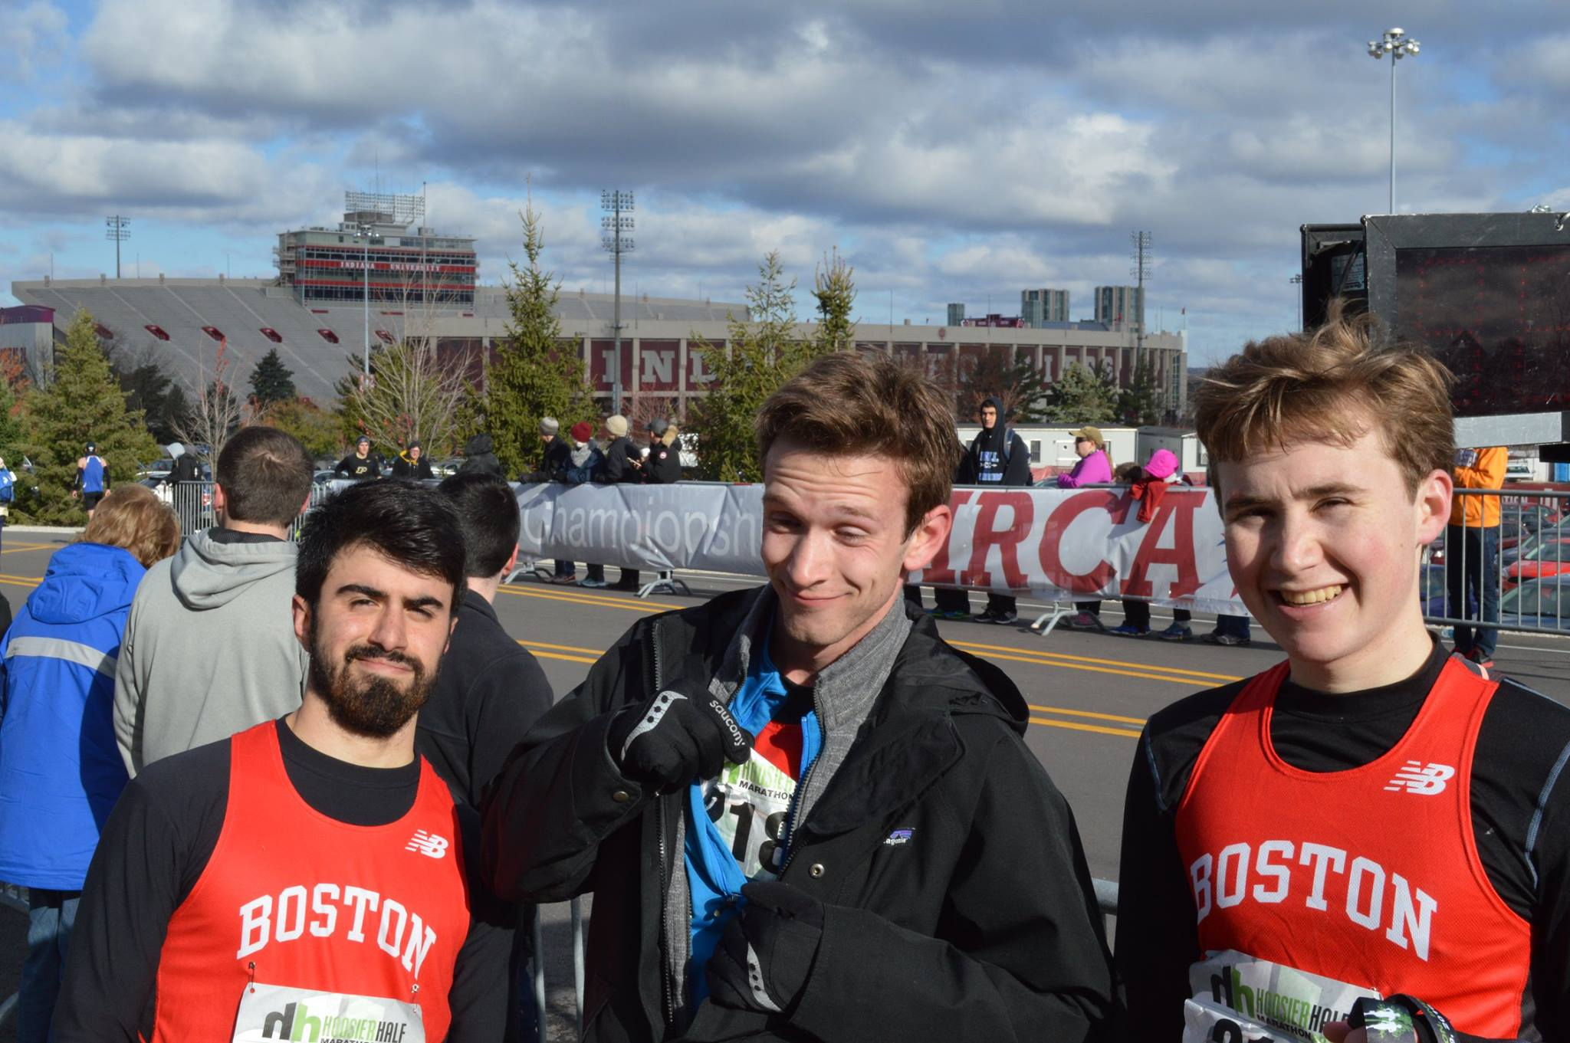
Half Marathon Boys on the course

4/16/2016
Ten of our club members selflessly woke up before the sun to volunteer for the Boston Athletic Association 5K, starting at 6 a.m. This race is part of the Boston Marathon series, and brings the most elite runners of the world to Boston. This event was very rewarding to be a part of the Boston running community and experience the atmosphere of a huge running event (there were tens of thousands of runners and spectators). We hope to use this as a stepping stone to volunteer at more local races and expand our connection to the local running community.

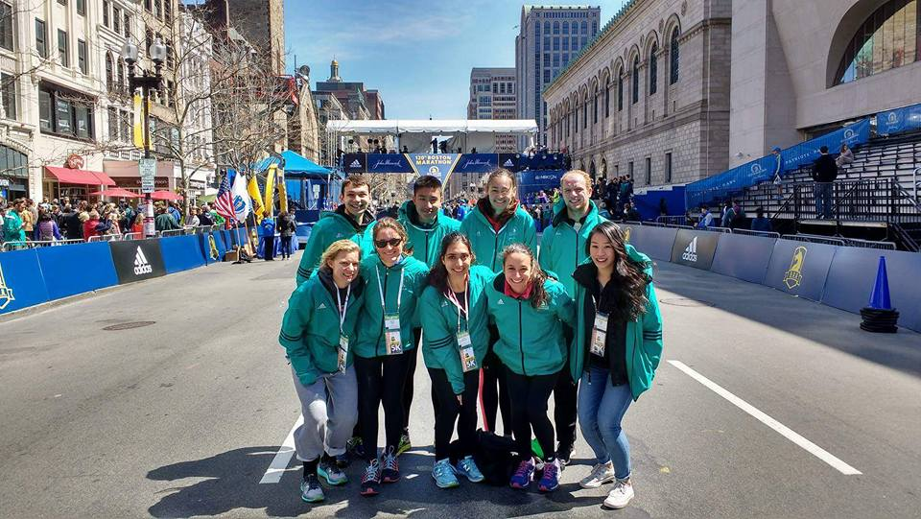
Our volunteers pose in front of the Boston Marathon finish line

4/23/2016
A few committed members competed at the Regis Pride Classic meet, concluding our season as a club. Riley Pihl set a new club record in the 5000 with a 15:58.78, and finally bested Nate Michener (16:06.96) in their last club race. Annie Lane continued to grow her talents as a runner, setting a personal best in the 5000 meters with a 24:02.19.

--Written by Ryan Smith

Social Events:

Running is a shared activity which serves as a connection for our members, but additionally our club promotes a strong social component (also runners are just awesome people to hang out with). Bonding is important to us both inside and outside of meets and practices. We host countless social events throughout the year, both formal and informal, planned and spontaneous, ranging from nightly team dinners, ice skating, weekend long runs and movie nights, nacho night at a local restaurant, team formal and banquet, attending other BU sports events, and holiday-themed events (secret Santa, Friendsgiving, etc.). Some of these events are subsidized by membership dues. At our club formal, the last event of the year, we watched a slideshow consisting of memorable photos, handed out team awards to our graduating seniors and our outstanding competitors, and announced funny team superlatives for each of our active members. We are all looking forward to welcoming a new freshman class to our club, and to see each other at a social event next year!

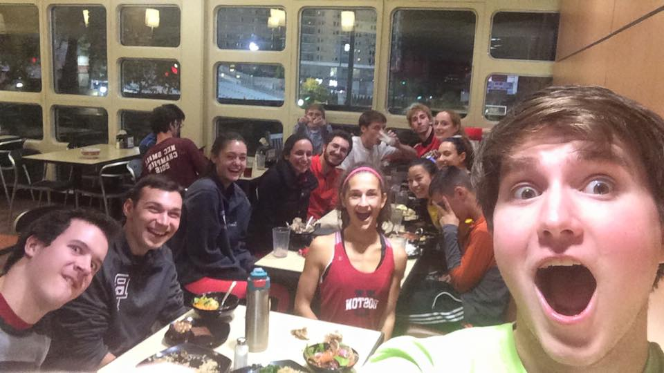
Team Dinner at the West Campus Dining Hall
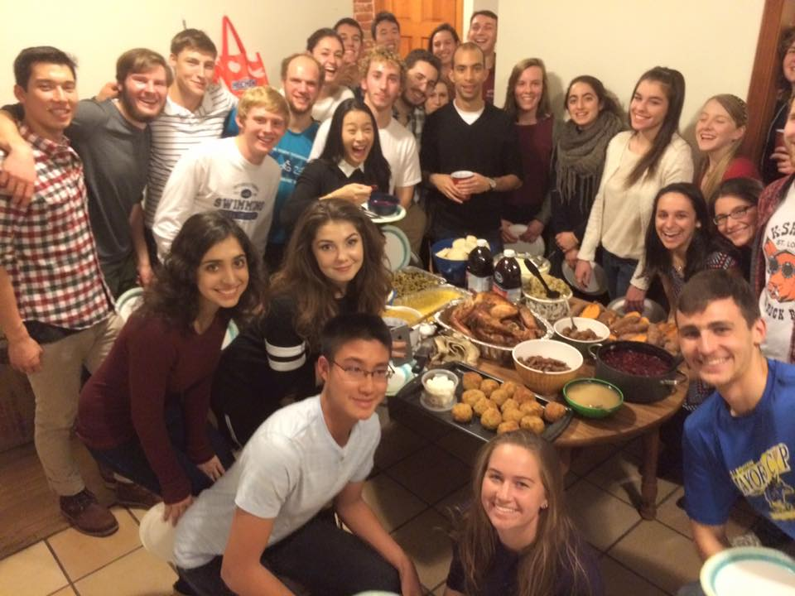
Team Friendsgiving
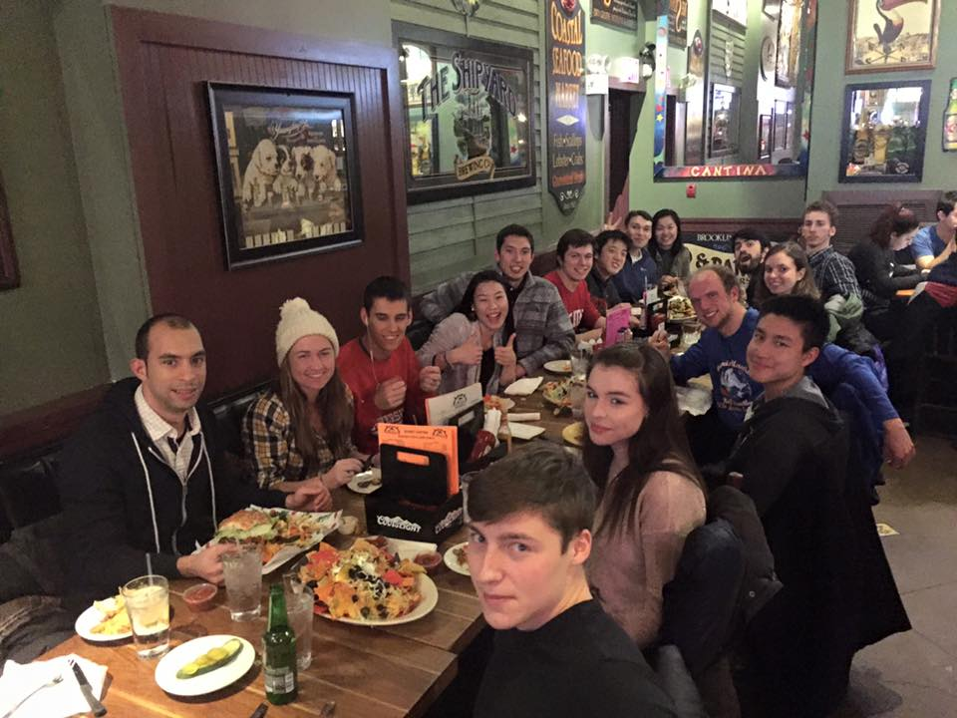
Team Nacho Night at Sunset Cantina

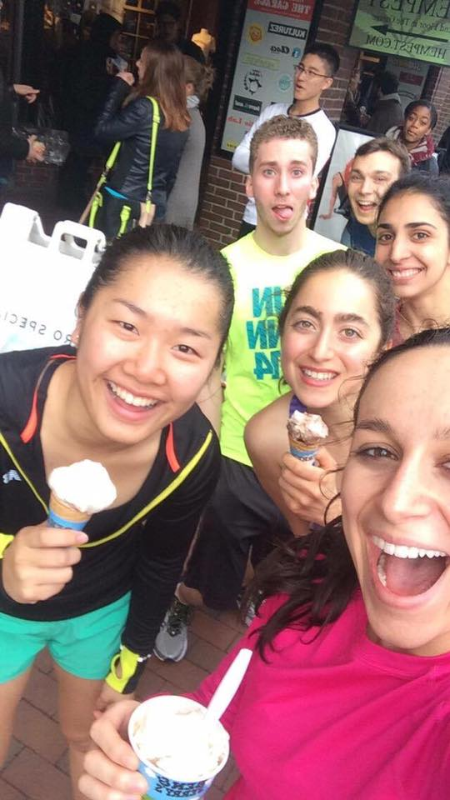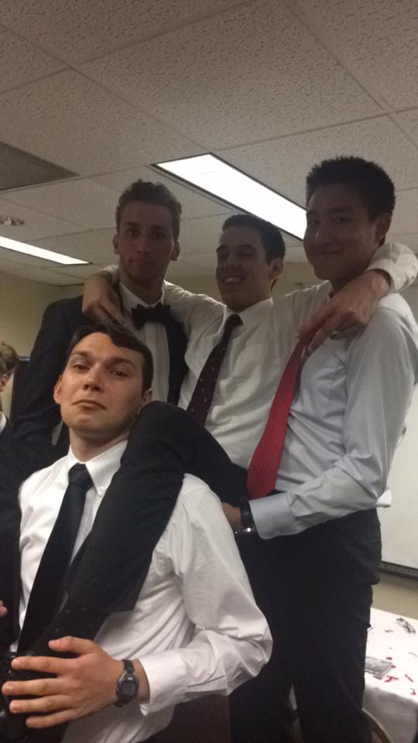
Ben & Jerry's Ice Cream Run Running Club Formal

Executive Board:

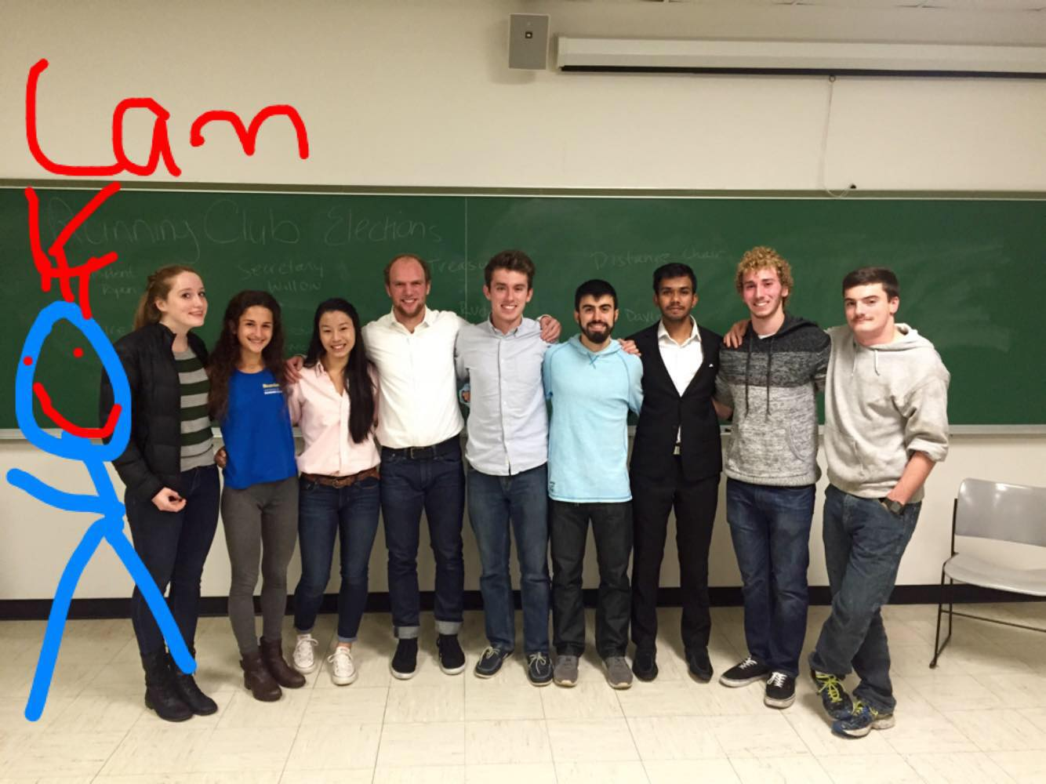
President: Ryan Smith
Vice President: Matt Mirek
Secretary: Willow Yeoh
Treasurer: Anirudh Sriram and Erik Wong
Workout Chairs: David Martinez and Cam Baxter
Social Chair: Lorela Blaka and Annie Geasa
Public Relations Chair: Aaron Gladstein
Health and Wellness Chair: Jake Simon
Team Captains: James Lane, Sandra Wilson, Annie Geasa, Nathan Weinberg, Andrea Castano, Daniel Kelly
Recreational Chair: Annemarie Parsons
Club Founder: Nicole Milani

